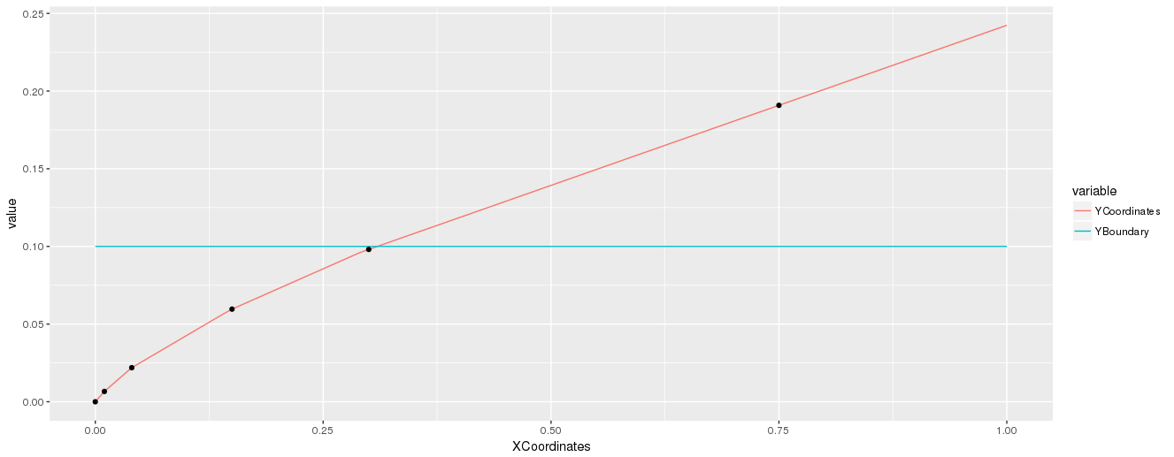
$PlansChangingPoints
[1] 0.00 0.01 0.04 0.15 0.30 0.75

$Plans
$Plans[[1]]
[,1] [,2] [,3] [,4]
[1,] 0 0 0 0
[2,] 0 0 0 0
[3,] 0 0 0 0
[4,] 0 0 0 0
[5,] 0 0 0 0

$Plans[[2]]
[,1] [,2] [,3] [,4]
[1,] 1 0 0 0
[2,] 0 0 0 0
[3,] 0 0 0 0
[4,] 0 0 0 0
[5,] 0 0 0 0

$Plans[[3]]
[,1] [,2] [,3] [,4]
[1,] 2 0 0 0
[2,] 1 0 0 0
[3,] 0 0 0 0
[4,] 0 0 0 0
[5,] 0 0 0 0

$Plans[[4]]
[,1] [,2] [,3] [,4]
[1,] 3 0 0 0
[2,] 2 0 0 0
[3,] 1 0 0 0
[4,] 0 0 0 0
[5,] 0 0 0 0

$Plans[[5]]
[,1] [,2] [,3] [,4]
[1,] 4 1 0 0
[2,] 3 0 0 0
[3,] 2 0 0 0
[4,] 1 0 0 0
[5,] 0 0 0 0

$Plans[[6]]
[,1] [,2] [,3] [,4]
Right Skew Tri distribution
[1,] 4 1 1 0
[2,] 3 0 0 0
[3,] 2 0 0 0
[4,] 1 0 0 0
[5,] 0 0 0 0

